Bear Lake
Kalkaska County, MI

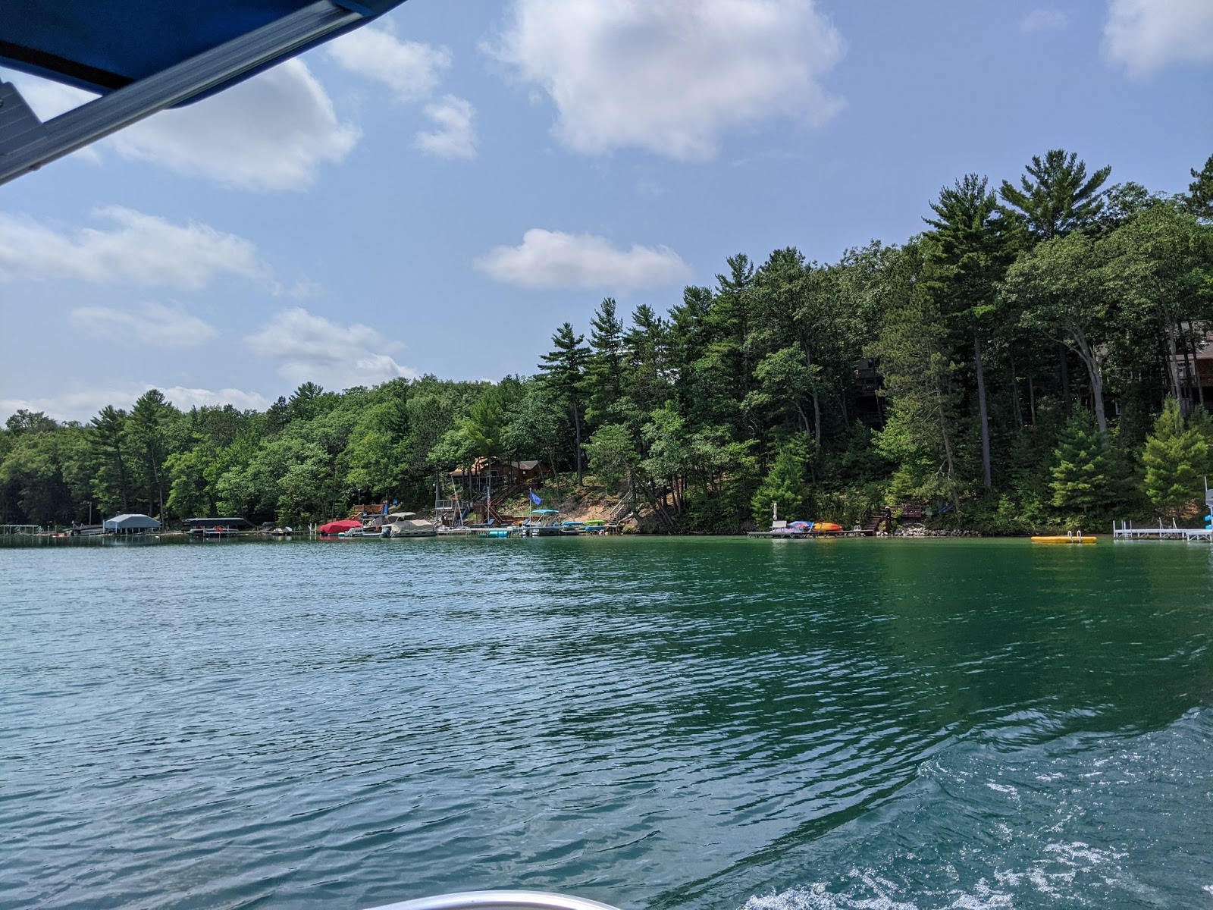

Au Sable Institute Summer Session II
Lake Ecology Report
8 August 2021

Au Sable Institute of Environmental Studies
Megan Schroeder (Olivet Nazarene University)
Cassandra Van Putten (Cornerstone University)

Introduction

Bear Lake is a glacial lake found in Kalkaska County in the northwestern, lower peninsula of Michigan (Figure 1). It has a relatively round perimeter with residences along the majority of the shoreline. Bear Lake doesn’t have inflow or outflow streams but does have a small pond attached to the southwest end of the lake called Eleanor Bay (Figure 2). The average depth of Bear Lake is about 11 meters, while the maximum depth is around 18.5 meters. Bear Lake is thermally stratified during the summer, which means it has epilimnion, metalimnion, and hypolimnion zones. The epilimnion is the zone of the lake from the surface to the thermocline, or the depth where the temperature starts decreasing by at least 1℃ per meter depth. The thermocline defines the metalimnion, so the end of the thermocline marks the end of the metalimnion. These two zones provide habitat and resources for gamefish including various bass species, yellow perch, and pumpkinseed sunfish. The hypolimnion is the deepest part of the lake below the thermocline. Bear Lake’s depth allows it to support cold-water fish such as rainbow and brook trout.
The geology of a lake has a major impact on the water quality and biological diversity of the lake. Bear Lake is a glacial kettle lake, formed after glaciers moved through the area and a piece of ice broke off, compressing the ground below. The ice melted, leaving behind a depression in the land that filled with groundwater. Because there are no outflow or inflow streams to the lake, its watershed is also an important factor in the health of the lake. Bear Lake has a relatively large watershed, which influences the types and amounts of nutrients and other chemicals in the water entering the lake. Rain and runoff flow easily into the body of water as the surrounding area is primarily hills made of marl and sand.
Our class sampled Bear Lake on July 27, 2021 and collected the main part of our data. We returned on August 3, 2021 to obtain more plankton samples and to analyze the chemical profile of the lake. Overall, our results show Bear Lake to be a healthy oligo-mesotrophic lake, with a high biodiversity of organisms.

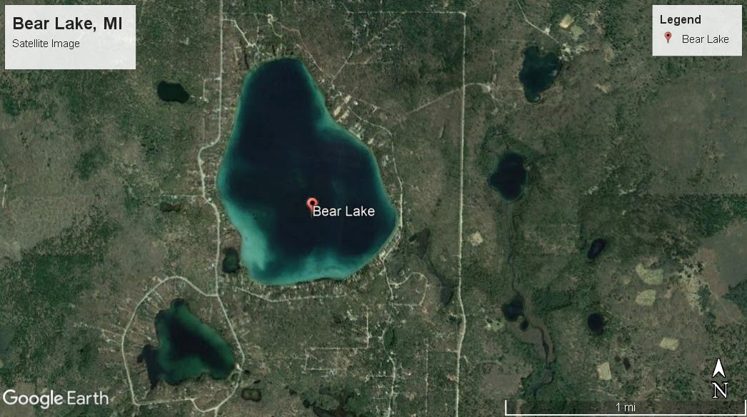
Figure 1. Aerial satellite photo of Bear Lake and the surrounding area. (image from Google Earth).

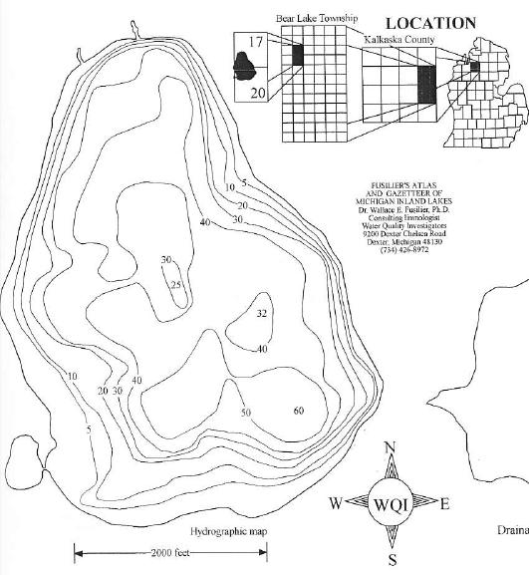
Figure 2. Location of Bear Lake in Michigan and a morphometric map of the depth. (source: https://www.bearlakeassoc.com/lake-facts).

Materials and Methods
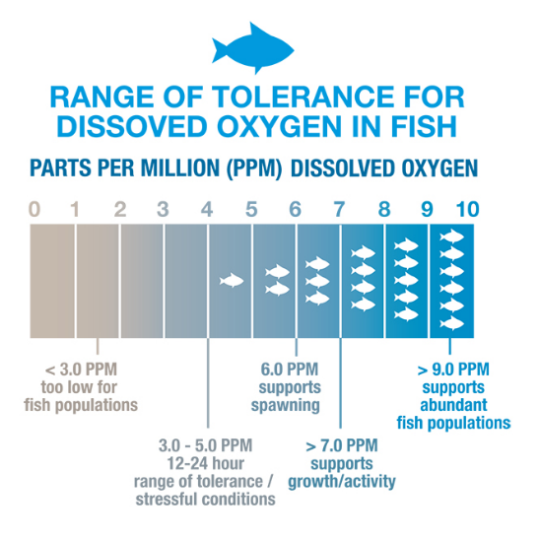
Our class used two residents’ pontoons to sample the lake: Sam Rahaim and Rich Vervisch. We collected samples on July 27 and August 3, 2021.

Dissolved Oxygen and Temperature
Dissolved Oxygen is a vital measurement when determining the overall health of an aquatic ecosystem. It informs us about the distribution of animals, presence of photosynthesis, where decomposition occurs, and its influences on chemicals and nutrients. Oxygen can be dissolved into a body of water two different ways: through the mixing of air and water, or from photosynthesis in plants and phytoplankton. Temperature and dissolved oxygen levels are connected, though, as at higher temperatures less oxygen can be dissolved in the water.
Figure 3. Chart describing the tolerance of fish at different dissolved oxygen concentrations (source: https://www.water-research.net/index.php/dissovled-oxygen-in-water).
Aquatic animals require the presence of dissolved oxygen and tend to succeed in waters with higher levels. Figure 3 shows the effects of varying levels of dissolved oxygen on aquatic animals.
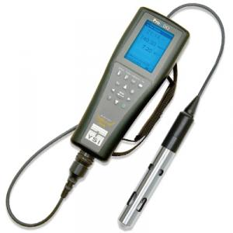
Temperature also plays a significant role in the distribution of nutrients. In the summer, the heating of lakes due to sunlight and warmer air temperatures causes thermal stratification. This means that since at different temperatures water has different densities, when the surface of the lake is warmed, the warmer water stays on top, while water at the bottom of the lake is the densest, with temperatures approaching 4०C. When this happens, the uptake of nutrients and oxygen by organisms in different zones of the lakes cause deficiencies in that zone that cannot be replenished until the fall or spring when the water throughout different depths reaches the same temperature.
Figure 4. YSI electronic probe used to measure temperature, dissolved oxygen, and percent saturation (source: https://envcogl obal.com /catalog/w ater/water-quality-handhelds/ysi-handhelds /pro odo-handheld-optical-dissolved-oxygen-meter).
Lakes are divided into three zones based on temperature and depth. At the surface, the epilimnion is the warmest zone where there is little to no change in temperature. At the metalimnion, the presence of the thermocline is indicated by a temperature change of 1 ०C or more per meter of depth. The hypolimnion is the deepest zone that also has little to no change in temperature. The water in the hypolimnion is the densest, as there is a change in water density with temperature. The presence of the thermocline indicates thermal stratification, a phenomenon occurring in the summer months when the sun warms the surface of the lake, causing varying water densities from surface to bottom that prevent mixing of the layers. This is a natural process that is present in most northern lakes.
We measured dissolved oxygen and temperature using a YSI electronic probe, shown in Figure 4. The probe at the end is lowered meter by meter to obtain readings for temperature in degrees Celsius (०C) and for dissolved oxygen in parts per million (ppm) and percent saturation (% sat). We measured every two meters from the surface to the bottom.

Results and Discussion - Dissolved Oxygen and Temperature
The Bear Lake Sample Data 2021 graph shows the dissolved oxygen (indicated by the orange line) and temperature (indicated by the blue line with diamonds) with depth. Both show little variation in measurement until 8 meters when temperature decreases significantly. As temperature decreases, we also observe a large increase in dissolved oxygen for the next 2 meters. Following the peak in dissolved oxygen at a depth of 10 meters, it steadily decreases until reaching the bottom where there is still some oxygen present in the water. Temperature decreases until 10 meters as well, though there is little variation in temperature from 10 meters until reaching the bottom. Dissolved oxygen also indicates natural biological processes occurring within the layers of the lake. The increase and peak of the graph show that there is a high amount of primary production taking place between 8 and 12 meters. As phytoplankton photosynthesize, they take up carbon dioxide and return oxygen to the water. The significant decrease in dissolved oxygen indicates a high amount of decomposition at the bottom, a process that uses oxygen and emits carbon dioxide.
In 2014, the difference between dissolved oxygen at the surface and bottom was much less than it is now. Figure 15 shows a trend of increasing difference between surface and bottom dissolved oxygen. This means that more biological activity is present and organic matter at the bottom that uses the dissolved oxygen in the water than in years past.
Figure 15. Scatter plot comparing dissolved oxygen data from 2014 to 2021.

Water Transparency (Secchi Depth) & Trophic State Index
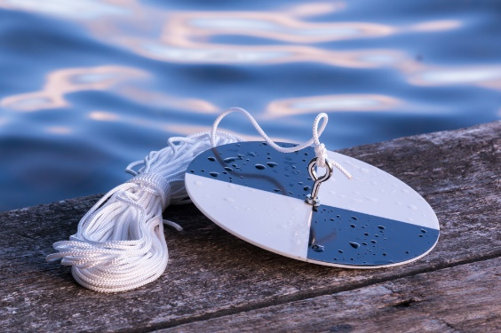
In order to measure the relative transparency of the water, we used a Secchi Disk, shown in Figure 5. This test shows what kind and the relative quantity of matter present in the water, particularly phytoplankton. To perform the test, the black and white disk, attached to a rope, is lowered meter by meter into the water until it is no longer visible. If the Secchi Disk is only visible between 0.1-2 meters, the lake is considered eutrophic, while visibility between 8-40 meters qualifies as an oligotrophic lake. Eutrophic lakes have low visibility as a result of increased nutrients, therefore an increased amount of phytoplankton in the water, while oligotrophic lakes lack a high quantity of nutrients, so have fewer particles suspended in the water.
Figure 5. Secchi disk used to measure relative transparency (source: http://generic .wordpress.soton.ac.uk/discoveroceanography/for-teachers/workbook-2/secchi-disk/).
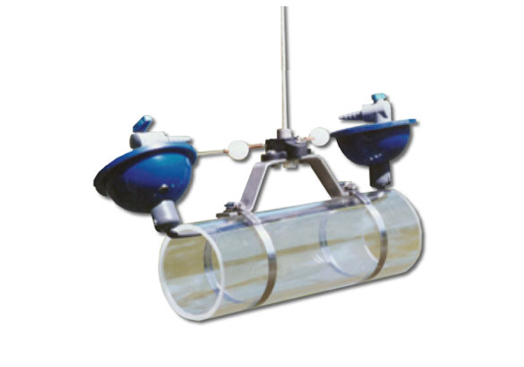
Using the measurement from the Secchi Disk, we can then calculate the Trophic State Index (TSI). This is a classification system that considers the amount of biological activity present in order to rate a body of water. It can be calculated using Secchi Depth, Chlorophyll concentration, or Total Phosphorus. For our calculation, we used Secchi Depth. We used the equation TSI= 60 - (14.41*ln[Secchi Depth]) to calculate the TSI from Secchi Disk measurements. While the range for classification can be from 1-100, a lake with a TSI less than 30 has low nutrients and production rates but is usually preferred for water sports because of its clarity. Lakes that have a TSI range between 50-100 have high nutrients and primary production but have significantly lower visibility.
Figure 6. Van Dorn Bottle Sampler, used to take water samples at depth (source: https: //ecoenvironmental.com.au /product/water-monitoring/van-dorn-sampler-2/).

Results and Discussion - Secchi Depth and Trophic State Index
This year, our Secchi Disk was visible to 7.5 meters. Using the equation to calculate Trophic State Index: TSI= 60 - (14.41*ln[Secchi Depth]), we found that TSI= 31.0. This indicates an oligo-mesotrophic lake. Bodies of water in this range usually have a moderate amount of nutrients and are reasonably productive, able to support a fair amount of wildlife such as plankton, insects, fish, and birds.
Figure 16. Scatter plot showing the trend of TSI values from 2014 to 2021
Since sampling began in 2014, the Trophic State Index fluctuated between 27.6 and 36.8. Figure 16 shows the variation from 2014 to 2021. Each year is expected to be slightly different based on the conditions throughout the season in addition to variation in the weather on sampling days. Visibility and clarity of the lake are easily impacted by sunlight. Since our TSI only considers the Secchi Depth and data is only collected once per summer instead of an average of weekly measurements, it is natural to see changes year to year.

Alkalinity and Hardness
Alkalinity is a measurement of the ability of the water to act as a buffer or resist changes in pH. Lower alkalinity means that the pH of the lake is more susceptible to change quickly if acids or bases enter the lake. This is an issue when acid rain is present.
Hardness is a measure of Calcium and Magnesium ions present in a solution. Excess amounts of calcium or magnesium can lower the toxicity of other metals to life in the lake or take important nutrients out of the water.
Figure 7. HACH test kit, used to test alkalinity and hardness (source: https://www.amazon.com/Hach-2063700-Alkalinity-Model-AL-DT/dp/B00N3 Z1FVC).
Lakes in Northern Michigan tend to have higher alkalinity and hardness due to limestone bedrock forming in a region that was previously coral reefs. When limestone (calcium carbonate; CaCO3) dissolves in water, it dissociates and increases both hardness and alkalinity.
To measure the alkalinity and hardness in Bear Lake, we sampled from surface to bottom, taking water samples every 4 meters. To obtain water samples below the surface, we used a Van Dorn Bottle Sampler (Figure 6). Then, using Hach Titration Kits (Figure 7), we tested for alkalinity and hardness.

Results and Discussion - Alkalinity and Hardness
We measured alkalinity and hardness at the surface, followed by samples every 4 meters until reaching the bottom, and found that both were consistent, showing little variation in the data. In Figure X, alkalinity is indicated by the green line with circles and hardness by the light blue line with x’s. To fit properly on the figure, the total value measured was divided by 10, but the trends for both are still the same.
The average alkalinity is 81.4 ppm CaCO3. A healthy lake has alkalinity in the range of 20-200 ppm CaCO3; lakes in Northern Michigan are usually between 80-130 ppm CaCO3. This indicates that the lake is capable of accepting protons, acting as a buffer against pollutants such as acid rain.
The average hardness is 97.2 ppm CaCO3. “Hard” water ranges between 120-180 ppm CaCO3, while “soft” water ranges between 0-60 ppm CaCO3. Most lakes in Northern Michigan are between 80-120 ppm CaCO3.
Historically, the region was underwater, covered by coral reefs. This causes the bedrock now to be made of limestone, which is primarily calcium carbonate. As lakes are formed and water dissolves the rock, it causes higher amounts of carbonate and calcium ions, which in turn increases alkalinity and hardness, respectively. This means that Bear Lake is more resistant to changes, allowing it to support a more stable ecosystem.

Light
Light is significant to determine where we would expect primary production to occur. Because light is necessary for photosynthesis, photosynthetic organisms (primarily phytoplankton), will be in areas of higher light. This can also be used to determine whether a lake is oligotrophic or eutrophic based on the amount of primary productivity taking place.
We measured light penetration every two meters using a Protomatic light photometer (Figure 8).
Figure 8. Protomatic light photometer, used to measure light penetration (source: personal photo).

Results and Discussion - Light

Figure 14. Graph comparing the trends of temperature, pH, oxygen, hardness, light saturation, and alkalinity to Bear Lake depth.
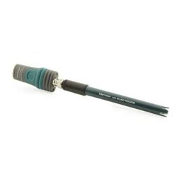
We observed a decrease in light from the surface to bottom of the lake, indicated by the gray line with triangles on Figure 14. This is expected, as the light is scattered by particles in the water. For photosynthesis to occur, light penetration must be deep enough to reach the metalimnion where most of plankton reside. At the dissolved oxygen peak, the light is still 18% of the surface light, which means that this is sufficient to support photosynthetic organisms.

pH, Conductivity, & Redox
In optimal conditions, the pH of the lake water is between 6 and 9. The pH changes frequently throughout the season, potentially even day to day. It is critical to consider when analyzing the concentration of chemicals present. This relates to the conductivity and redox potential of water as well, as different compounds are formed or broken down depending on the pH of the solution. If chemicals are entering the lake, monitoring of pH can be an indicator of potential fertilizer runoff.
Figure 9. Vernier GoDirect wireless probe, used to measure pH, conductivity, and redox potential (source: https://www.vernie rcanada. ca/pro duct/sensors/go-direct-sensors/go-direct-conductivity-probe/).
To measure pH, conductivity, and redox we used Vernier GoDirect Wireless Probes (Figure 9) from the surface to bottom, taking samples every 4 meters.

Results and Discussion - pH, Conductivity, Redox Potential
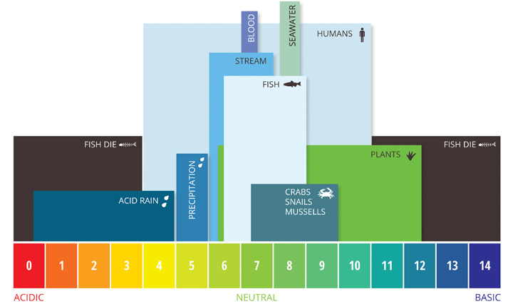
pH, conductivity, and redox potential play a role in the different processes within a lake ecosystem. The pH is significant to biological interactions and can be an important indicator of contaminants entering a body of water. Most lakes have a pH between 6.5-9, while acid lakes are less than 5 and soda lakes are greater than 10. At pH levels outside of 6-9, primary production begins to fail as plants struggle, causing adverse effects throughout the trophic system. Figure 17 shows the levels of pH acceptable for different forms of life. Bear Lake has a healthy pH around 8, indicating proper chemical interactions occurring to sustain life within the aquatic ecosystem.
Figure 17. A bar chart showing the different pH tolerances of organisms and causes of pH change. (source: https://www.fondriest.com/environmental-measurements/parameters/water-quality/ph/)

Conductivity is another indicator of potential pollutants. An increase in conductivity is usually a result of human disturbance. If significant changes are present, we would be concerned about impairment of biological processes within the ecosystem. Fortunately, conductivity in Bear Lake is consistent throughout, indicating no source of pollution that impacts it currently.
Redox potential is important in the cycling of micronutrients in lakes due to its influence on the biogeochemical processes occurring in the lake. At higher dissolved oxygen concentrations, the redox potential also increases. At low dissolved oxygen concentrations, the redox potential is lower. To analyze its impact on the micronutrients, it is important to observe the redox potential at the bottom of the lake where many chemical reactions between nutrients occur. In oligotrophic lakes, we expect to see a redox potential between 300 to 450 mV, allowing reactions to occur that would avoid eutrophication (excess of nutrients) in lakes. However, we measured the redox to be 105 mV at the bottom, shown in Table 1. Due to the low dissolved oxygen measured at the bottom, we anticipated a lower redox potential present. This does not indicate an unhealthy lake but does caution against chemical pollutants as fewer reactions will take place at lower redox potentials to decrease the ions present.

Depth | pH | Conductivity (µS/cm) | Redox Potential (mV)
Surface | 7.9 | 183 | 55
Bottom | 8.12 | 166 | 105
Table 1. A comparison of the pH, conductivity, and redox potential at the surface and bottom of the lake.

Plankton
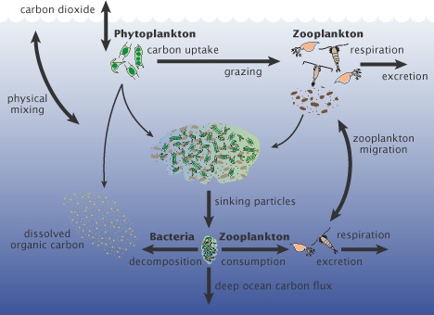
Diversity and abundance are an important part of any ecosystem. Samples of phytoplankton and zooplankton can tell us about the health of the system within the lake. If a diverse and abundant sample is present, the lake is likely to have plentiful nutrients, therefore considered a eutrophic lake.
Plankton are an important foundation for a lake. The phytoplankton are microalgae and serve as primary producers and a food source to larger organisms. They are an important sink of carbon dioxide, as they take it up during photosynthesis and produce oxygen. The most common groups of zooplankton are the Cladocera, Copepods, which are microcrustaceans, and Rotifers. The zooplankton are the center of the lake food system, eating the bacteria and algae in the water, and getting eaten by fish, insects, and larger zooplankton. A graphic of this system is indicated on Figure 18. Many species of zooplankton are transparent to avoid predation.
Figure 18. Diagram of the cycle between carbon and zooplankton. (source: https://www.earthobservatory.nasa.gov/featur es/Phytoplankton/page2.php)
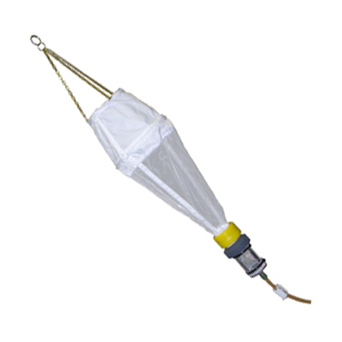
Using an 80 μm mesh plankton net (Figure 10), we collected a sample of phytoplankton and zooplankton by lowering the net from surface to bottom three times. We brought the sample to our lab and preserved it for observation under a microscope.

Results and Discussion - Plankton
Figure 10. Plankton net, used to sample phyto and zooplankton (source: https://envcog lobal.com/c atalog/term/water/limnology/plankton-equipment/plankton-nets).
We looked at the phyto and zooplankton of Bear Lake and found eight species of phytoplankton and ten species of zooplankton. Some of the most common phytoplankton species we found include Gleocapsa, Crucigenia, and Fragilaria; Figure 20 shows the percent abundance of various species of phytoplankton found. Similarly, Figure 21 demonstrates the percent abundance of zooplankton, with the most common species being Synura, Polyarthra, and Ceratium. Some images of phyto and zooplankton are shown in Figure 19.
We did not observe any species that would cause concern to the health of Bear Lake or its residents; there is a healthy amount of biodiversity present, particularly for an oligotrophic lake.

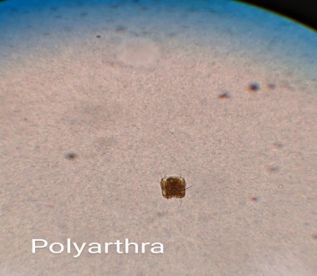 | 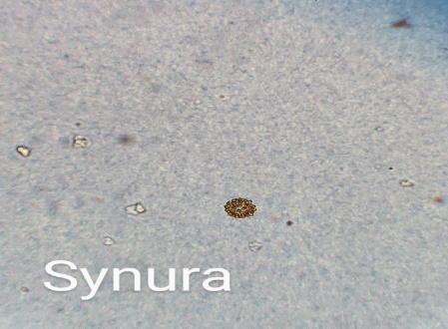 | 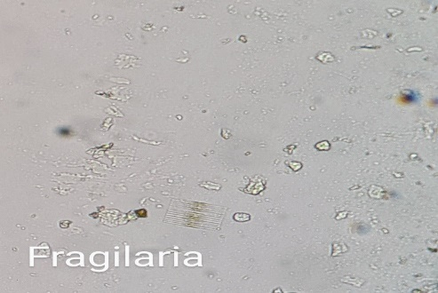 | 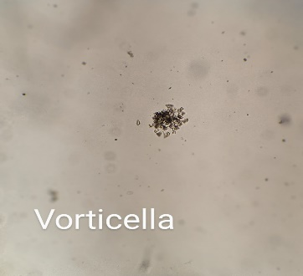 | 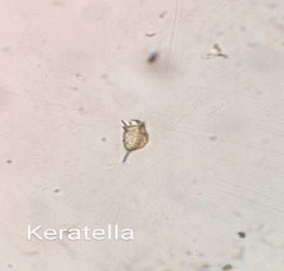
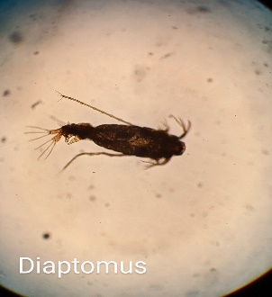 | 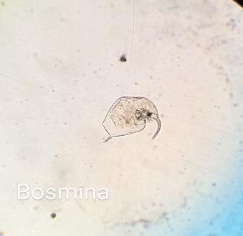 | 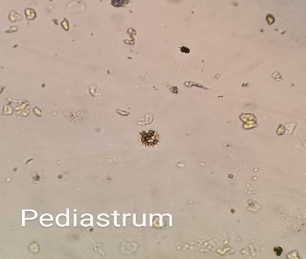 | 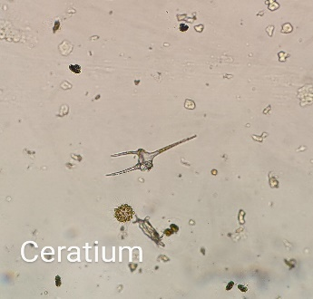 | 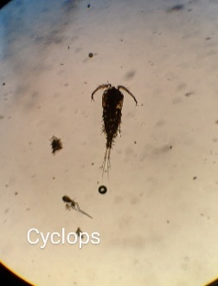
Figure 19. Pictures and genus names of some phytoplankton and zooplankton observed from the Bear Lake samples (source: personal photos).

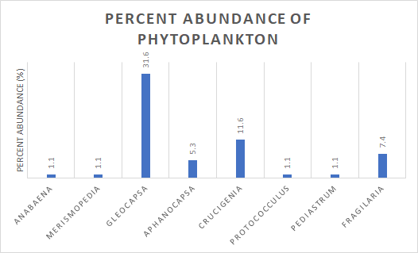
Figure 20. Graph of the relative abundance of the phytoplankton genus found in Bear Lake.

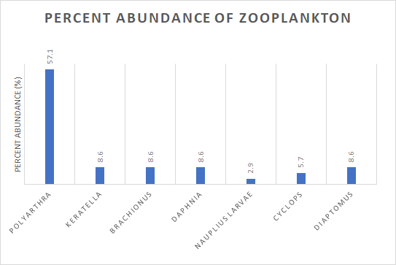
Figure 21. Graph of the relative abundance of zooplankton genus found in Bear Lake.
Coliform Bacteria
Coliform bacteria are bacterial colonies made up of multiple species. These colonies can include both fecal coliform bacteria and non-fecal coliform bacteria. Fecal coliforms are naturally occurring bacteria found in the intestines of warm-blooded animals, including birds and humans and can be either disease causing or harmless. If fecal coliform bacteria are present, it indicates human or animal fecal contamination in the water.
To analyze for coliform bacteria, we used Coliform Easygel, taking two 3 mL samples at each of our three different sites around the lake: East Shore, the public access beach, and near the peninsula between the lake and Eleanor Bay. Each sample was taken back to the lab and placed in the incubator at 37 ०C for 24 hours. After 24 hours, we counted the colonies present. If a colony appears pink or red, it is a general coliform, but a purple or blue colony indicates a fecal coliform.
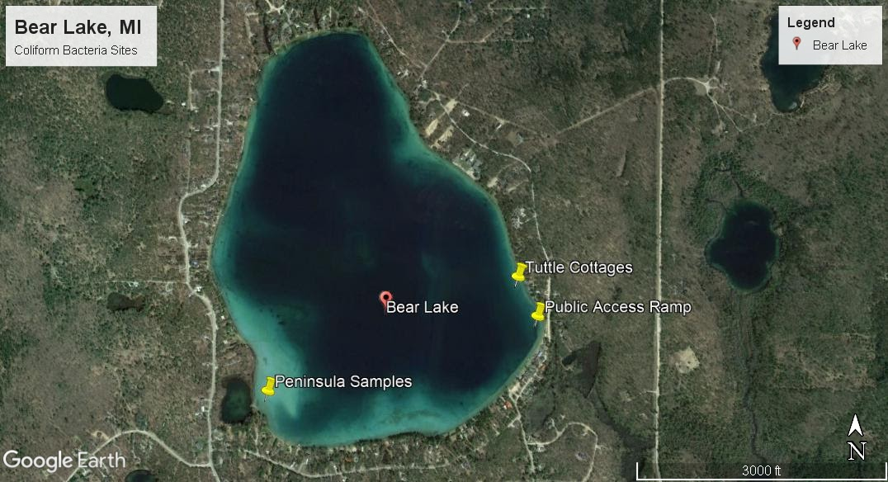
Figure 11. Aerial satellite map of Bear Lake with pins on the locations of fecal coliform samples.

Results and Discussion - Coliform Bacteria
Out of a total of six samples at three locations in Bear Lake, fecal coliform appeared in two. Table 2 shows two samples for each location and the quantity of colonies present in a 100 mL sample. Blue or purple colonies indicate fecal coliform, while pink and red colonies indicate non-fecal coliform. Since our sample size was 3 mL, the quantities we counted are multiplied by 33.3 to demonstrate the amount of coliform bacteria present in a 100 mL sample size.
Escherichia coli, commonly known as E. coli is one of the most common fecal species of coliform bacteria and is used as an indicator organism for bacterial tests because it grows easily and can imply that sewage may be present in the water. The maximum acceptable levels for E. coli in recreational waters is 88 per 100 mL sample. There was one sample from the Peninsula that cultured 100 fecal coliforms, which does exceed the recommended safe levels. It is important to note the loon nesting site in close proximity to our sampling location, which may have contributed to the spike in fecal matter. Caution should be taken, though, as E. coli demonstrates the likelihood of contracting water- borne diseases through the bacteria present.
We recommend further testing of the waters at various locations around the lake to monitor levels of coliform bacteria present. It is important to recognize that while fecal matter may be an indicator of faulty sewage systems, it is also excreted by warm blooded animals, including waterfowl, humans, or pets. Continued sampling will present a better analysis of the concerns regarding the quantity of fecal coliform present in our samples.

Table 2. Shows the location, amount, and type of bacteria colonies found in Bear Lake.
Location | Blue and Purple Colonies  Bacteria/ 100 mL | Pink and Red Colonies  Bacteria/ 100 mL
East Shore Cottages A | 0 | 33
East Shore Cottages B | 0 | 33
Public Access A | 0 | 0
Public Access B | 66 | 0
Peninsula A | 100 | 66
Peninsula B | 0 | 0

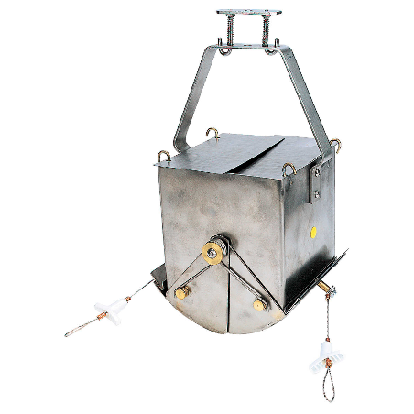
Benthic
Benthos are organisms that live at the bottom of the lake. They are important indicators of the health and status of a lake as they will not survive if conditions are poor at the bottom such as little to no oxygen. They are also one of the most stable parts of the ecosystem because of how difficult it is to change the conditions at the lower layer, particularly in deep lakes.
To sample organisms in the benthic zone, we lowered an Ekman Dredge (Figure 12) to the bottom of the lake, pulling matter from the benthic zone to the surface. This was placed into a sieve bucket to isolate the organisms collected.
Figure 12. Ekman dredge, used to sample the benthic zone (source: https://www.forestry-suppliers.com/product_pages/products.php?mi=50071).

Results and Discussion - Benthos
Benthos samples are an important indicator of the health of the lake. When dissolved oxygen is present in considerable concentrations at the bottom of a lake, then benthic organisms will be present. In our sample, we found two blood worms and a snail. Bloodworms are good indicators of lake health; they tell us that there is enough oxygen at the bottom of the lake which also indicates that fish can survive in the deeper areas.
We identified the snails collected near shore as the Banded
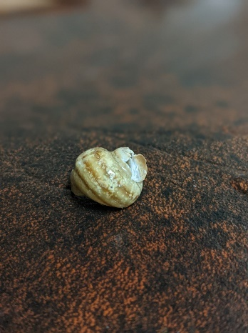 | 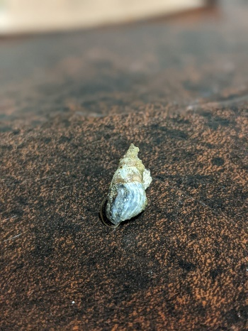
Banded Mystery Snail | Liver Elimia
Mystery Snail (Viviparous georgii) and the Liver Elimia (Elimia livescens). The Banded Mystery Snail is a species introduced to the Great Lakes region. These snails can host a variety of parasites in addition to predating upon fish embryos. However, research shows no indication of detrimental effects from Banded Mystery Snails on lakes to date. Liver Elimia is a native species of snail. They are not tolerant of pollution or low oxygen conditions, so their presence is a sign of a healthy lake. In our samples we did not find any zebra mussels, though past AuSable students and lake residents have identified them in previous years.
Table 3. Comparison of the snail species found in Bear Lake
(source: personal photos).

Algae
Resident Sam Rahaim noticed an unknown algal growth on the bottom near his shore. We waded 5 meters offshore and used a clean bottle to obtain a sample of the algae. This was brought back to the lab and preserved for observation using a microscope.
Algae is a natural part of a lake ecosystem. Algae are microscopic single-celled photosynthetic organisms. Some species will grow in colonies, filaments, or mats. They are an important part of the ecosystem as producers of oxygen and as a food source for plankton and other aquatic invertebrates. Algae can also be used as indicators of water quality as some species are sensitive to changing pH, nutrient levels, and temperature.
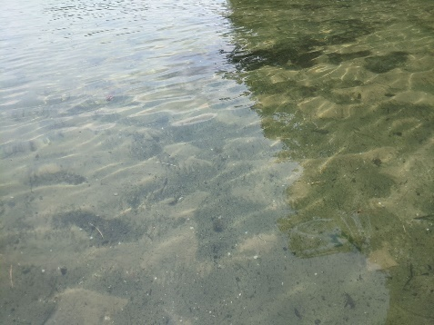
Results and Discussion - Algae
The algae we identified is the genus Synerdra, which is a golden-brown algae. This algae is responsible for making the water turn to more of a brown color. Currently there is not much research on this type of algae or its effects, so we are unable to give any conclusive evidence about its effects on the lake’s ecosystem.
Figure 22. Picture of the algae near Sam R.’s dock (source: personal photo).

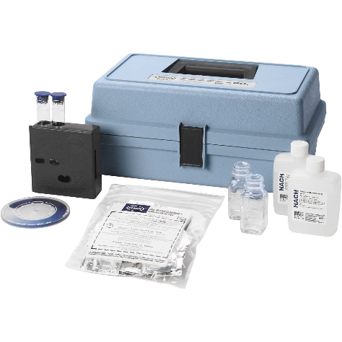
Phosphate
Phosphates play a significant role in the growth of phytoplankton and aquatic macrophytes in a body of water. They are the primary limiting nutrient, which means that excess phosphates can have detrimental effects on the ecosystem.
Phosphate is an important test to perform to analyze potential pollutants from runoff within the watershed. Since phosphate is a limiting nutrient for phytoplankton and aquatic vegetation, it is important to minimize the quantity in the water to avoid eutrophication of the lake. We would expect more phosphate to be present at the bottom of the lake due to the low redox potential but did not perform an orthophosphate test for that region of the lake.
Figure 13. HACH test kit used to test for orthophosphates (source: https://www.forestry-suppliers.com/product_pages/products.php?mi=54201).
We conducted a test for the phosphates present in the lake using a CHEMets Phosphate K-8510 Kit (Figure 13). This test only analyzes the orthophosphates present, which are the ones that are dissolved in the water. The amount of soluble phosphate is close to the total phosphate levels, allowing it to be an acceptable indicator of the amount present.

Results and Discussion - Phosphates
Our orthophosphate test did not indicate any significant levels of phosphate present in the water. This means that at the surface, dissolved phosphate is negligible.

Recommendations and Conclusion
Bear Lake is a healthy oligo-mesotrophic lake, evident through our sampling and analysis of the data. Dissolved oxygen levels, one of the most critical measurements in water quality analysis, indicates proper amounts of biological activity to sustain other aquatic organisms. The Secchi Disk and Trophic State Index, though, show that the lake maintains a healthy equilibrium.
While Bear Lake residents practice good management strategies, there are some points in our data analysis to suggest close monitoring in the future. While the quantity of fecal coliform levels is not an immediate concern, if continued growth of the colonies may pose a danger to both the biological activity within the lake and to humans interacting with it. We also note the lower redox potential at the bottom of the lake that is consistent with eutrophic lakes. Because of this, there is a possibility of eutrophication, or an overabundance of nutrients occurring in the lake. At a low redox potential, phosphates present in the water do not react with other ions, causing it to mix when the lake is the same temperature from surface to bottom in the spring and fall. The lake is more susceptible to pollutants as redox potential decreases. It is critical to avoid the use of phosphate fertilizers as the watershed is vulnerable to runoff entering the lake, in addition to monitoring and upkeep of septic tanks within the watershed. Both fertilizer runoff and septic tank leakage would have detrimental effects on the lake, leading to an overabundance of nutrients that would cause algal blooms. This would ultimately alter the use and recreation on Bear Lake.
As water levels of the lake continue to rise, it is also vital to protect the shoreline from erosion. At some residences there is clear evidence of bank erosion and sedimentation. While we did not perform a shoreline analysis, it is still important to engage in practices that can better protect your shore from erosion and its negative impact on the lake. While leaving the shoreline in its natural state is the best option to protect your banks, we understand that it may not be feasible for some. Other options are to plant native species to hold sediment in place or adding log berms or fallen dead trees as a natural form of wake protection.
Waterfront property owners are stewards of the lake; you have a responsibility to do your part in protecting Bear Lake. Awareness is the first step, but conscious efforts must be made to ensure the longevity of the lake for both human recreation and for the natural ecosystem. Avoid the use of fertilizers, invest in proper septic tank management practices, and implement shoreline protection to prevent erosion. Doing so will promote a productive coexistence of plant, animal, and human life for residents of Bear Lake to enjoy!

Acknowledgements
We would like to thank Dr. John Korstad for teaching us the knowledge and skills required for this project, and for helping us identify the plankton and algae.
Thank you to Sam Rahaim and Rich Vervisch for donating their time to take the Lake Ecology Class out on their boats and talking to us about the history of the lake.
Thank you to the rest of the Lake Ecology & Management class for aiding in the sampling and recording of data for this project.
Thank to Dr. Brian Keas for helping us with identifying the snails from the lake.

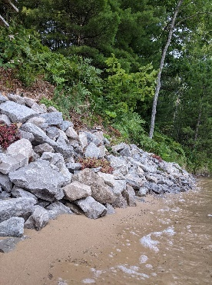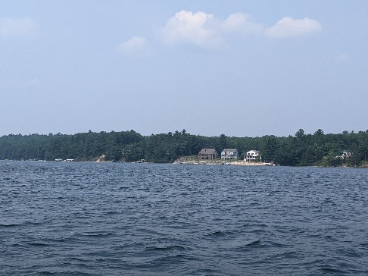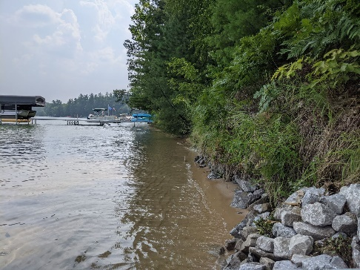

Sources

Addressing Total Coliform Positive or E.Coli Positive Sample Results in EPA Region 8 | US EPA. https://www.epa.gov/region8-waterops/addressing-total-coliform-positive-or-ecoli-positive-sample-results-epa-region-8. Accessed 9 Aug. 2021.
“Difference Between Coliform and Fecal Coliform.” Compare the Difference Between Similar Terms, https://www.differencebetween.com/difference-between-coliform-and-vs-fecal-coliform/. Accessed 9 Aug. 2021.
EAI Analytical - Recreational Water Testing. http://eai-labs.com/services/recreational_water.html. Accessed 9 Aug. 2021.
Florida, USF Water Institute, School of Geosciences, University of South. Learn More: Trophic State Index (TSI) - Lake County Water Atlas - Lake.WaterAtlas.Org. http://www.lake.wateratlas.usf.edu/library/learn-more/learnmore.aspx?toolsection=lm_tsi. Accessed 9 Aug. 2021.
Freshwater Algae: Native Plants. https://www.doc.govt.nz/nature/native-plants/freshwater-algae/. Accessed 9 Aug. 2021.
Hardness and Water Quality. http://www.state.ky.us/nrepc/water/ramp/rmhard.htm. Accessed 9 Aug. 2021.
Invaders on the Move: Mystery Snails and White Perch - MSU Extension. https://www.canr.msu.edu/news/invaders_on_the_move_mystery_snails_and_white_perch. Accessed 9 Aug. 2021.
Laboratory, NOAA Great Lakes Environmental Research. NOAA National Center for Research on Aquatic Invasive Species (NCRAIS). https://nas.er.usgs.gov/queries/greatlakes/FactSheet.aspx?Species_ID=1047&Potential=N&Type=0. Accessed 9 Aug. 2021.
“Lake Facts | Bear Lake Association - Kalkaska, Michigan.” Bear Lake Association, https://www.bearlakeassoc.com/lake-facts. Accessed 9 Aug. 2021.
Liver Elimia (Elimia Livescens) - Species Profile. https://nas.er.usgs.gov/queries/FactSheet.aspx?SpeciesID=2233. Accessed 9 Aug. 2021.
PH of Water - Environmental Measurement Systems. https://www.fondriest.com/environmental-measurements/parameters/water-quality/ph/. Accessed 9 Aug. 2021.
Well Testing | Wells | Private Water Systems | Drinking Water | Healthy Water | CDC. 10 Oct. 2018, https://www.cdc.gov/healthywater/drinking/private/wells/testing.html.
What Are Phytoplankton? NASA Earth Observatory, 16 July 2010, https://www.earthobservatory.nasa.gov/features/Phytoplankton/page2.php.
Zooplankton and Fresh Water: Here Are the Facts | International Institute for Sustainable Development. https://www.iisd.org/articles/zooplankton-and-fresh-water. Accessed 9 Aug. 2021.

